15.50: The amplitude given is not needed, it just ensures that the wave disturbance is small. Both strings have the same tension 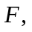 and the same length 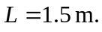The wave takes different times 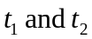 to travel along each string, so the design requirements is 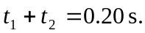Using 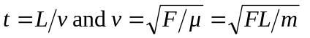  Solving for gives 